SIMATS ENGINEERING
ASSESSMENT TOOL 2: Industry Problem-Based Assignment
COURSE NAME: ARTIFICIAL INTELLIGENCE COURSE CODE: MLA01
AND EXPERT SYSTEMS

COURSE OUTCOME COVERED
CO 5: Construct rule-based expert systems using production rules, forward and backward chaining, and by distinguishing procedural and non-procedural paradigms across development stages.(BTL 3)
Assessment Tool Weightage: 40%

Total Marks: 100 Time: 90 Mins
No. of Questions: 1
Annexure A
Industry Problem-Based Assignment

Code of Conduct:
I ____________________ (Name / Reg No) certify that this submission is my original work and that I have adhered to the guidelines specified for this assessment.
I understand that any violation of academic integrity rules will result in disciplinary action. Signature of the student:
Criterion | Weightage | Marks Obtained
1. Problem Analysis and Domain Understanding | 10%
2. Knowledge Acquisition and Knowledge Representation | 10%
3. Production Rule / Knowledge Base Design | 15%
4. Prolog Implementation and Programming | 15%
5. Forward Chaining Implementation and Demonstration | 10%
6. Backward Chaining Implementation and Demonstration | 10%
7. Procedural and Non-Procedural Paradigm Analysis | 10%
8. Unification, Backtracking and Inference Accuracy | 10%
9. Testing, Results and System Demonstration | 5%
10. Documentation, GitHub Repository and Technical Presentation | 5%
Total | 100%
Signature of the Faculty Total Marks Awarded
Industry Domain | Real-World Problem Statement
Automobile Industry | A vehicle service center receives customer complaints such as engine overheating, difficulty starting, abnormal noise, low mileage, and warning-light activation. Develop a Prolog-based expert system that identifies probable vehicle faults and recommends appropriate diagnostic actions using production rules and logical inference.

PROLOG-BASED EXPERT SYSTEM FOR VEHICLE FAULT DIAGNOSIS
1. Title, Abstract & Introduction
Abstract
This project develops a rule-based expert system for preliminary vehicle fault diagnosis. It analyzes common symptoms and identifies probable faults with suitable diagnostic actions.
Introduction
Automobile fault diagnosis requires technical knowledge and experience. An expert system can represent this knowledge using rules and logical inference to support technicians during preliminary diagnosis.
2. Problem Statement & Objectives
Problem Statement
Develop an expert system that analyzes symptoms such as overheating, starting difficulty, abnormal noise and low mileage to identify probable vehicle faults.
Objectives
- Identify probable vehicle faults.
- Represent diagnostic knowledge using rules.
- Apply forward and backward chaining.
- Recommend diagnostic actions.
- Test the system using real-world cases.
3. Domain Analysis & Knowledge Acquisition
Domain: Automobile Fault Diagnosis
Inputs: Overheating, starting difficulty, abnormal noise, low mileage, warning light, weak battery and low coolant.
Outputs: Probable fault and recommended action.
The knowledge base contains vehicle symptoms, faults and relationships between them.
4. Knowledge Representation & Production Rules
The system uses facts and production rules.
Examples:
- Overheating + low coolant → Cooling-system problem
- Starting difficulty + weak battery → Battery problem
- Starting difficulty + clicking noise → Starter problem
- Abnormal noise + low oil → Low-oil problem
- Low mileage + poor acceleration → Fuel-system problem
5. Expert System Architecture
User → Symptoms → Knowledge Base → Inference Engine → Diagnosis
- User: Provides symptoms.
- Knowledge Base: Stores rules.
- Inference Engine: Applies rules.
- Output: Displays fault and recommended action.
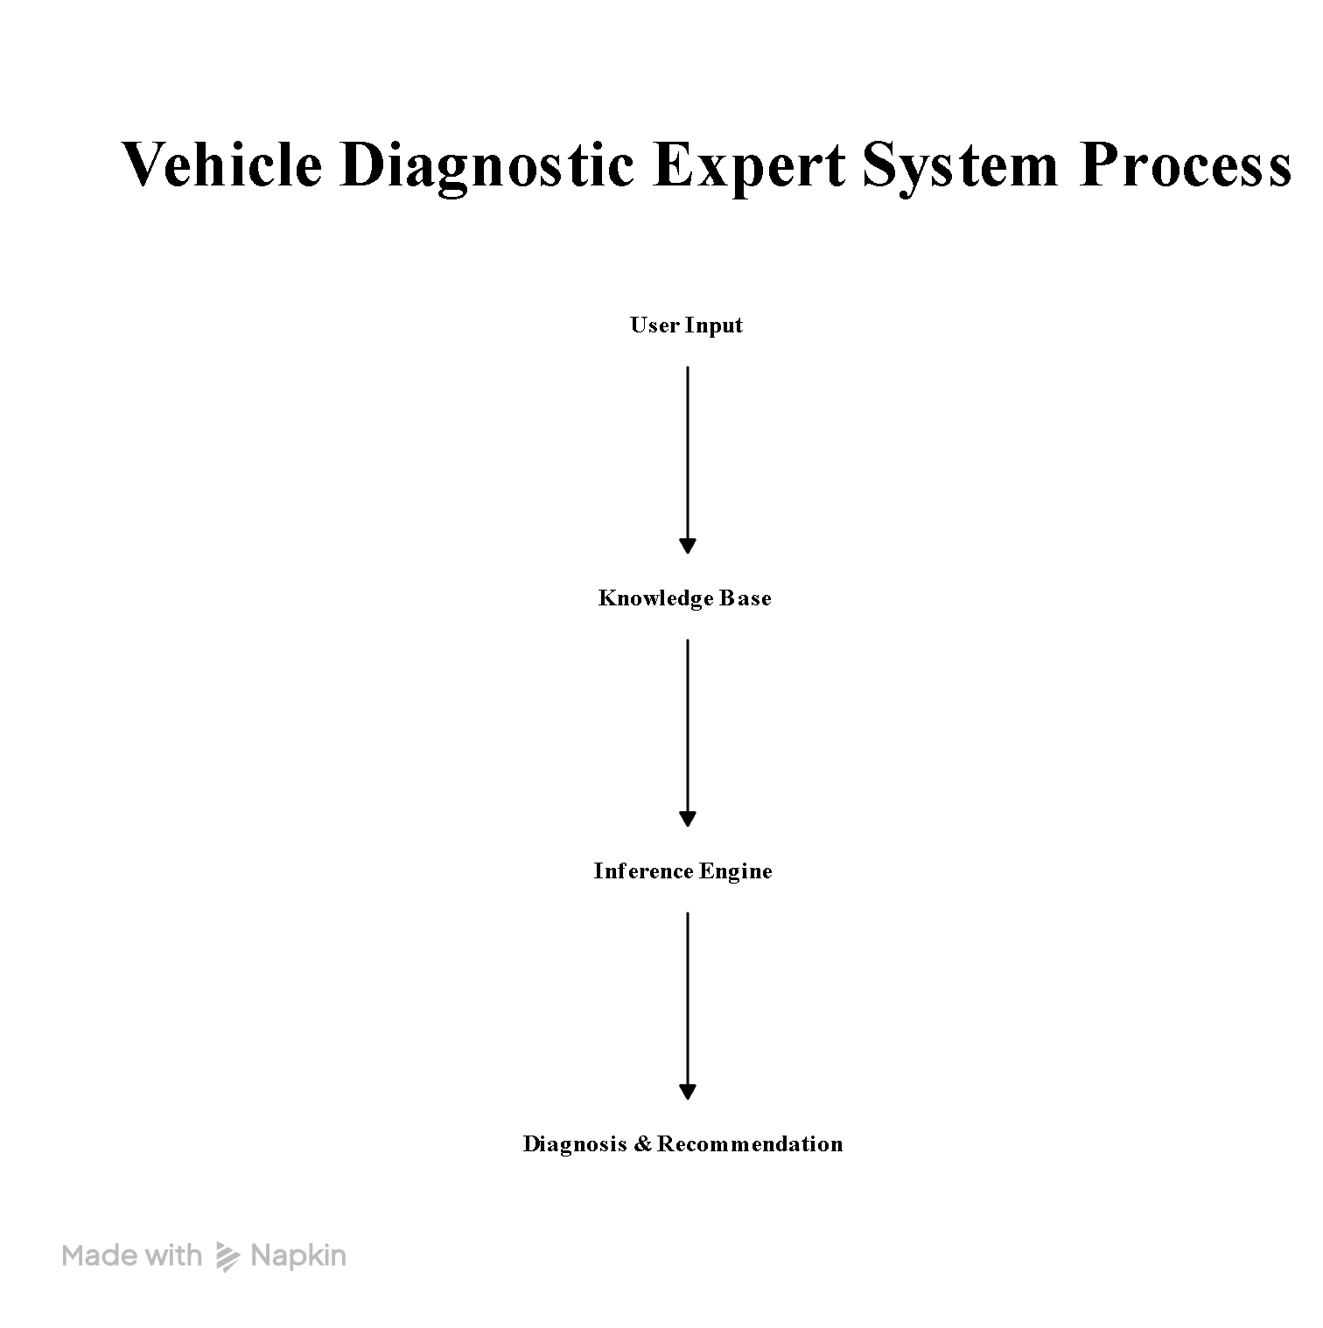
The assignment requires these main expert-system components.
6. Inference Mechanism & Algorithms
Forward Chaining
Starts with known symptoms and applies rules to reach a diagnosis.
Example:
Overheating + Low coolant → Cooling-system problem.
Backward Chaining
Starts with a possible fault and checks whether its required symptoms are present.
Unification
Matches facts with rules and variables.
Backtracking
Allows Prolog to try alternative rules when a reasoning path fails.
7. Prolog Implementation
The system will be implemented using SWI-Prolog.
The implementation will contain:
- Facts
- Predicates
- Production rules
- Diagnosis queries
- Forward and backward chaining
- Unification and backtracking
Prolog code 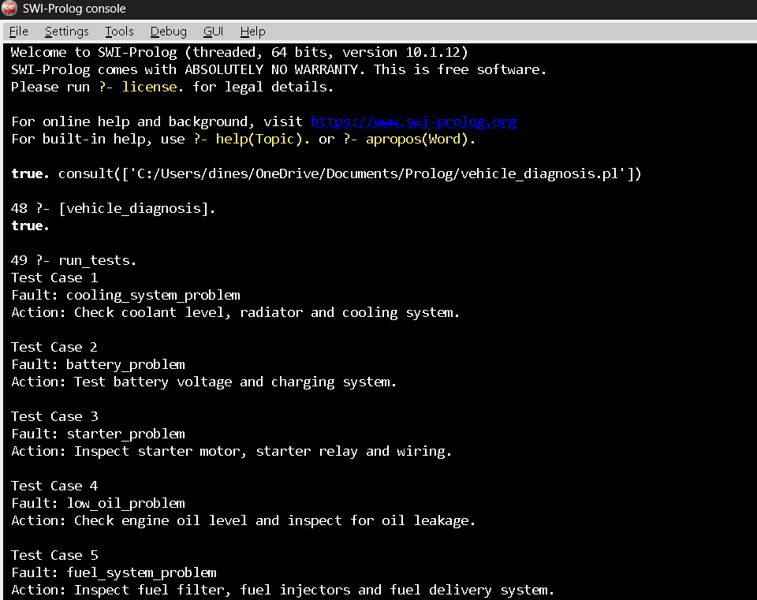
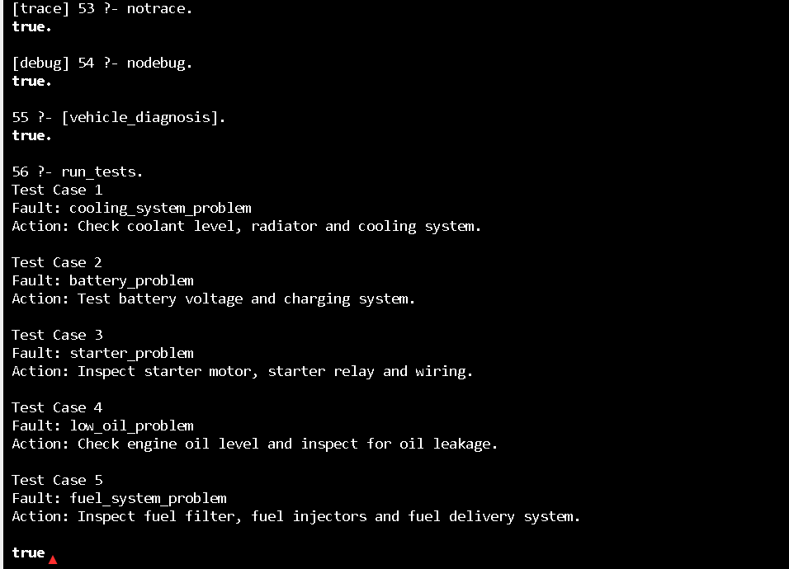
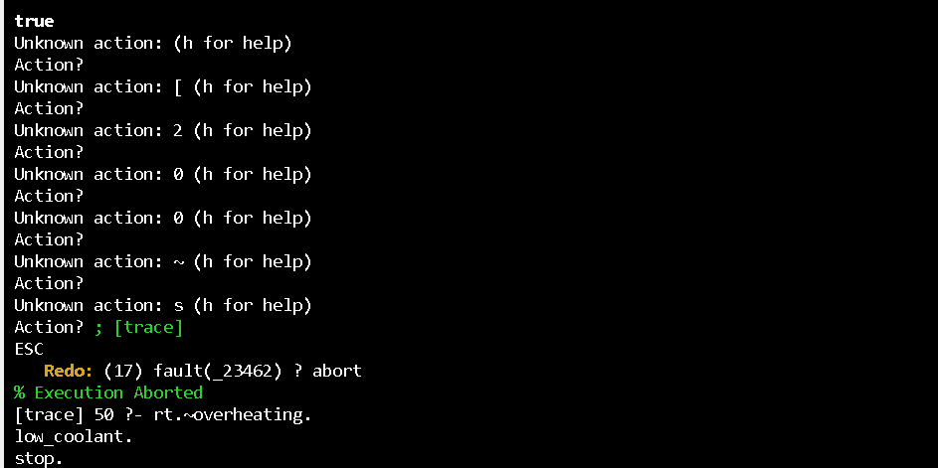

8. Test Cases & Results
Test | Symptoms | Expected Fault
1 | Overheating + Low coolant | Cooling-system problem
2 | Starting difficulty + Weak battery | Battery problem
3 | Starting difficulty + Clicking | Starter problem
4 | Abnormal noise + Low oil | Low-oil problem
5 | Low mileage + Poor acceleration | Fuel-system problem
All five predefined cases are expected to produce the correct diagnosis. The assignment requires at least five test cases.
9. Analysis, Limitations & Future Enhancements Analysis
The rule-based system provides simple and explainable preliminary vehicle diagnosis.
Limitations
- Limited knowledge base.
- No real-time vehicle data.
- Cannot replace professional inspection.
- Multiple faults may produce similar symptoms.
Future Enhancements
- OBD-II integration
- Real-time sensor data
- Machine-learning-based diagnosis
- Mobile application
- Larger fault database
Recent research also highlights AI-based vehicle fault diagnosis as an important direction for improving automotive maintenance.
10. Conclusion & References
Conclusion
The proposed expert system applies Artificial Intelligence and rule-based reasoning to automobile fault diagnosis. It identifies probable faults from symptoms and recommends suitable diagnostic actions. The system can be extended with real-time vehicle data and AI techniques.
References
- SWI-Prolog, SWI-Prolog Reference Manual, 2025.
- SWI-Prolog, SWI-Prolog 10.0.0 Stable Release, 2025.
- Artificial Intelligence-Driven Vehicle Fault Diagnosis to Revolutionize Automotive Maintenance: A Review, Computer Modeling in Engineering & Sciences, 2024.
- SWI-Prolog Documentation, current documentation, accessed 2026.
Structure of the Report:
S.No. | Report Section | Expected Content
1 | Title, Abstract & Introduction | Project title, brief abstract, industry background, problem context, and importance of the selected problem.
2 | Problem Statement & Objectives | Clearly define the real-world industry problem, inputs, expected outputs, stakeholders, and specific objectives.
3 | Domain Analysis & Knowledge Acquisition | Identify entities, facts, conditions, decisions, and explain how domain knowledge was collected from reliable sources.
4 | Knowledge Representation &  Production Rules | Represent domain knowledge using Prolog facts, predicates, and production rules.
5 | Expert System Architecture | Provide and explain the architecture showing the user, knowledge base, inference engine, and output/explanation module.
6 | Inference Mechanism &  Algorithms | Explain and demonstrate forward chaining, backward chaining, unification, and backtracking with suitable algorithms/pseudocode.
7 | Prolog Implementation | Describe the SWI-Prolog implementation, important predicates/rules, queries, and provide the GitHub repository link.
8 | Test Cases & Results | Provide minimum 5 industry-based test cases, queries, expected outputs, actual outputs, and inference traces.
9 | Analysis, Limitations &  Future Enhancements | Analyze system effectiveness and reasoning accuracy; discuss limitations and propose future improvements.
10 | Conclusion & References | Summarize the developed expert system, major findings, industry relevance, and provide properly formatted references.

EVALUATION RUBRICS:
Criterion | Weightage (%) | Excellent | Good | Average | Poor
1. Industry  Problem  Analysis and  Understanding | 10% | 9–10% – Clearly identifies a relevant real-world industry problem, stakeholders, constraints, inputs, and expected decisions. | 7–8% – Good understanding with minor omissions. | 5–6% – Basic understanding with limited analysis. | 0–4% – Problem  is unclear, inappropriate, or poorly analyzed.
2. Domain  Knowledge and  Knowledge  Acquisition | 10% | 9–10% – Acquires comprehensive and reliable domain knowledge and  identifies relevant facts, entities, and relationships. | 7–8% –  Relevant knowledge is acquired with minor gaps. | 5–6% – Basic domain knowledge with limited sources. | 0–4% –  Insufficient, unreliable, or inappropriate domain knowledge.
3. Knowledge Representation and Production  Rules | 15% | 13–15% – Develops a complete, consistent, and well-structured Prolog knowledge base with appropriate facts, predicates, and production rules. | 10–12% – Well-designed knowledge base with minor omissions or | 7–9% – Basic knowledge base with several missing or unclear rules. | 0–6% –  Incomplete, inconsistent, or inappropriate knowledge representation.
4. Forward and  Backward  Chaining | 15% | 13–15% – Correctly implements and clearly demonstrates both forward and backward chaining with appropriate industry scenarios and reasoning traces. | 10–12% – Both mechanisms  are demonstrated with minor limitations. | 7–9% – Basic implementation with incomplete demonstration. | 0–6% – Chaining mechanisms are missing or incorrectly implemented.
5. Prolog Implementation and Inference | 15% | 13–15% – Effectively uses Prolog facts, rules, predicates, unification, backtracking, and inference to generate accurate conclusions. | 10–12% – Functional implementatio n with minor technical issues. | 7–9% – Basic implementation with limited use of Prolog features. | 0–6% –  Implementation is incomplete, incorrect, or non-functional.
6.  Industry-Based  Test Cases and  Results | 10% | 9–10% – Provides  diverse and realistic test cases with accurate queries, outputs, and detailed inference | 7–8% – Provides relevant test cases with mostly | 5–6% – Limited test cases and basic results. | 0–4% –  Insufficient or inappropriate testing.
7. Analysis and Interpretation of Results | 10% | 9–10% – Provides insightful analysis of reasoning accuracy, consistency, rule coverage, and practical | 7–8% – Good analysis with minor gaps. | 5–6% – Basic analysis with limited interpretation. | 0–4% – Results are poorly analyzed or not interpreted.
8. Procedural and  Non-Procedural  Paradigm  Understanding | 5% | 5% – Clearly explains and demonstrates the distinction between procedural and declarative/non-procedu ral approaches in the developed system. | 4% – Good conceptual distinction with minor gaps. | 2–3% – Basic understanding but limited application. | 0–1% – Incorrect or missing explanation.
9.  Documentation  , GitHub and  Technical  Presentation | 5% | 5% – Complete, well-organized report and GitHub repository with clear code, documentation, references, and professional presentation. | 4% – Good documentatio n and repository with minor issues. | 2–3% – Basic documentation with some missing components. | 0–1% – Poor documentation or missing GitHub repository.
10. Limitations,  Future  Enhancements and Conclusion | 5% | 5% – Clearly identifies practical limitations and proposes realistic, technically relevant future enhancements. | 4% –  Identifies relevant limitations and | 2–3% – Basic discussion of limitations and future scope. | 0–1% –  Discussion is missing or unrealistic.
Total | 100%

